Patent # 1 Interconnect and design hierarchy specification and generation patent

We will describe the concepts, current methodology and a new and improved methodology for the specification and generation of design hierarchy and interconnect for chip and system designs.

Chip designs can be described in both RTL (the hardware implementation) and C/C++ (the reference model). The design hierarchy and interconnect we describe is used for both the functional and synthesizable chip models.

The interconnection method separates the interfaces, design hierarchy, and connections between end points in a design. The method allows for rapid changes to any one of the three inputs (i.e. interfaces, design hierarchy, and connections) without having to change the other two inputs. This principle of separation allows for easier management of the design hierarchy will facilitates rapid changes, higher productivity, and lower maintenance costs. The interconnection method invented by FPL which separates the interfaces, design hierarchy, and connections between end points in a design.

The interconnect generation method described in this patent disclosure is applicable to any specific design platform (i.e. ASIC, custom VLSI, or FPGA, or any other device). The interconnect generation method described in this patent disclosure is applicable to any specific application (i.e. Multi media, processor, SoC, ASSP...), physical implementation, or design style.

This interconnect generation method is not limited to the generation of RTL. In fact the method is used to generate interconnect in different models not limited to but including C++ reference models, RTL designs, and pin outs for any type of semiconductor device.

FPGA IO Pads
FPGA's are constructed by connecting a functional block described in RTL which has been synthesized to I/O pads. RTL blocks contain ports which are multi bit. FPGA pads are single bit. The RTL multi bit ports need to be connected to a group of single bit ports. This is referred to as bit blasting. Therefor there is a need to have an efficient mechanism to create these types of complex connections.

1. General Definitions
- Design hierarchy
- Functional blocks
- Interconnect
- Block diagram
- Interfaces
- Ports/parameters/arguments
- Formals to actuals
- Connections

Design hierarchy
A design hierarchy has a hierarchy of functional blocks to manage the complexity of the underlying design.

Functional blocks
Functional blocks contain an interface for transferring information into and out of the block. The block implements an algorithm of set of functions which process the information transferred into the block.

Interconnect
Functional blocks are connected to one another to facilitate the transfer of information which is processed by an algorithmic implementation contained in the functional blocks.

Block diagram
Hardware designs can be represented with a block diagram that connect the functional blocks in the design. Each functional block is represented by a rectangle and contains the functional block and and instance name. The functional blocks are connected to one another using lines that are labeled with connection names. The lines are connected to pins in the functional blocks.

Interfaces
Interfaces contain the inputs and outputs of functional blocks in a design. Interfaces are used in both software and hardware to describe the inputs and outputs for a functional block or object. Interfaces in one functional block are connected to interfaces in other functional blocks. Interfaces contain one or more ports. Each interface contains ports. Multiple interfaces can be created.

Ports/parameters/arguments
Ports in an interface have a direction and optionally a width measured in bits.

Formals to actual name mapping
Actual names are parent ports, signals, expressions, or parts thereof. Formal names are the names of the ports in the instantiated object (child object).

Connections
The connection between two or more objects in a design hierarchy may traverse many units in a design hierarchy. The connection between the two objects may travel through many levels of the design hierarchy. The connections are compiled and the compiler generates detailed connections using instantiations with formal to actual name mappings and assign statements. Any changes to the connection must typically be made to each interface's formal to actual mapping for that connection.

What is an object?
The objects represent functional blocks in hardware and functions/classes in software. The objects may represent the actual functional blocks on the chip (hardware model) or a logical abstraction of the blocks in a reference model of the design (software model). Objects contain instantiations of other objects.

Instantiating objects
A parent object instantiates one or more child objects in the parent objects scope. The parent object connects parent ports, signals, expressions, or parts thereof to ports of the child instantiation(s) using formal to actual name mappings.

2. Current design methods

Issues with current design methods
The current process of creating a connection between objects in a design is labor intensive, inefficient, and error prone. Furthermore, the process of actually maintaining or changing the connections has the same issues.

Several different methods are used to create connections.

The first and most common method is to use a text editor with extensions for the RTL language that automatically creates the formal to actual connections for a single instance at a time. Each instance is processed in isolation without checking for possible conflicts with other instances. interfaces are created for each instance using macros or editor extensions.

The second method for creating connections is to use a script or program which reads each module's interfaces in the RTL code and then attempts to connect the same port names in different modules. If no match is found for a portname in a different instance in the design, a port is created in the interface of the top level functional block and the existing port name is connected to the new port. The act of creating a port where none is specified may or may not be the intension of the designer and can result in incorrect connections.

The third way connections are generated is with a simple specification language that is processed by a program or script which in turn generates RTL code. The language may have a connect by name feature. Some programs have a auto routing capability to route connections between two end points.

Typically the above programs generate one RTL language. Typically these programs do not have robust error checking. In order to implement robust interconnect error checking significant effort must be spent to build the data structures to represent the design internally in the tool.

The biggest draw back to the above three methods is that the methods are only used to generate the RTL interconnect and are do not generate the verification and functional simulation infrastructure. The programs do not generate the reference model code (i.e. C++ interconnect and vector generator) nor do they generate the testbenches.

Interconnect and design hierarchy information is used by three different teams on the project (design, functional simulation, and testbench team). Typically only one team automatically generates this information for its components and the other other teams end up manually creating an alternate model using the automatically generated information as a reference. The changes to the automatically generated design hierarchy and interconnect in the design domain must be propagated to the reference model and testbench domain manually.

A chip design is built by the design team (RTL design). An reference model is developed by the simulation team. The verification team typically will create the testbenches which connect the reference model to the RTL design.

The design teams use one of the above three interconnect capture and generation methods to capture the design hierarchy and interconnect.

3. New methodology
We have developed a new methodology to solve the problems associated with the old interconnect generation methods. We start with a language which is very compact and is based on C++ plus RTL extensions. The CSL interconnect specification is used by the other groups.
Therefor if you need to make any changes to the interconnect the changes are automatically propagated to the other parts of the chip project. The interconnect specification is reused by the other design and verification components unlike the old method which requires that designers and verification and simulation teams replicate the design hierarchy and interconnect.

Separation of Connections and Hierarchy
The new method relies on splitting the design hierarchy, interfaces, and connections into three separate inputs. Separation of the three inputs removes some of the dependencies between the inputs. The design hierarchy can change without changing the connections and the interfaces can change without changing the connections. Separation facilitates rapid changes and eliminates duplicate information. Connections are created using instance names in the design hierarchy and interfaces or ports.

The hierarchy can be changed and does not always affect the connections specification
Intermediate connections are created automatically. Intermediate connections details do not need to be provided since they are generated by a software tool.

If the two endpoints in the connection and the design hierarchy is known the detailed connections in the intermediate instances between the two objects are not included in the connection information. An "auto router" connects the two end points and creates the intermediate connections automatically while ensuring the the directions, types, and widths of the two endpoints are a match.

Interconnect Generation Flow
The below figure shows the flow for generating the RTL and reference model interconnect. The first step is to draw the block diagram. The second step is to create the hierarchy file, connection table, and interface file. An interface file contains interface type declations.

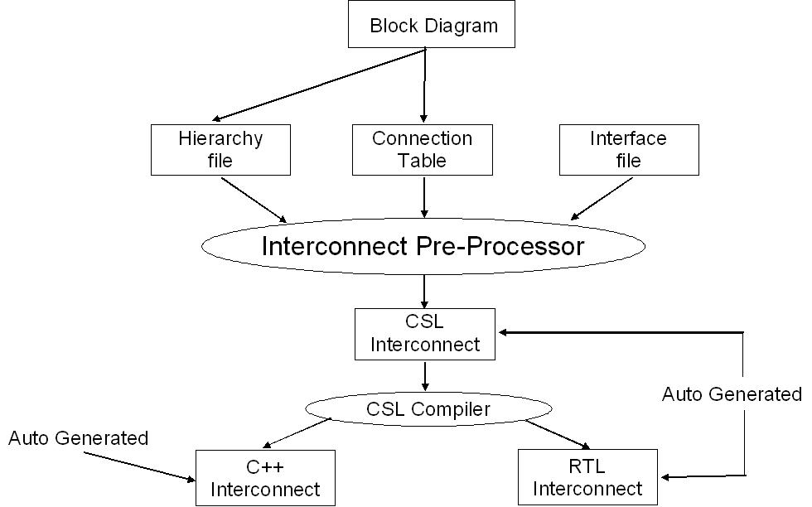
Hierarchy File
The hierarchy file contains the design hierarchy described using the module and instance names in a tree like notation. The design hierarchy is checked for cycles and for disjoint trees. The design hierarchy should be a single tree.

Connection Table
A connection table contains a list of connections. Each connection in the connection table is stored in a row. Connections are specified between different instances in a design hierarchy within the same level or across multiple levels. A connection is made using a connectable object. A connectable object is a signal, port, signal group, or interface. Each row in the connection table contains the interface or port type to instantiate in the the endpoints, the instance names of the interfaces or ports in the end points, and an optional actual name to use for the end points. An endpoint is a unit and the interface or port is added to the unit's list of local objects.

Interface library file
The interface library file contains the interfaces instantiated in the connection table. The interfaces contain ports. See above interface definition.

Preprocessor
The three input files are then processed by the preprocessor which creates the CSL interconnect code that contains the design hierarchy, the instantiated interfaces, the methods to reverse the interfaces at particular end points, and the connect statements. generated CSL code/object model is then compiled by the CSL compiler. The CSL compiler contains an auto router which creates the intermediate connections between the connect statement endpoints. The CSL compiler generates the RTL and reference model design hierarchy and interconnect code.

Connections
Connection specifications can be changed,added, deleted and do not affect the hierarchy. The following components of a connection object can be modified in the interface definition without affecting the connection.
- name
- width
- end points

Connection features
- CSL ports and interfaces can be connected via the CSL connect statement
- Two or more connectable objects may be connected with a single connect statement.
- Connectable object is a signal, signal group, port, interface, unit
- A connect statement eliminates the need to specify the detailed connections (formals to actuals, ports) in the intermediate instances between the two objects

Connection procedure
- The interfaces are added to each unit.
- One interface is in the source and the other interface is in the destination.
- A connect statement is used to connect the two end points (the interfaces).

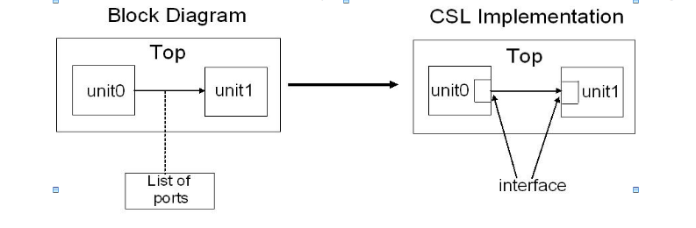
- The destination interface may or may not have to be reversed depending on the relationship between the two blocks (the ports are reversed to match the driver signals).
Auto router
The CSL compiler contains an auto router which creates the intermediate connections between endpoints specified by the Csl connection statements.
The auto router performs the following tasks.
- Connect end points in different units
- Make connections across hierarchies
- Connect any connectivity object (ports, signals, interfaces, etc.)
- The CSL "auto router" connects the two end points and creates the intermediate connections automatically.
- The CSL "auto router" connects the end points while ensuring the the directions, types, and widths of the two endpoints are a match.
- The design hierarchy is checked for cycles and for disjoint trees.

Inputs to new design process created by the user
- Block diagram with instance and unit names in boxes and lines connecting blocks or a text-based hierarchy file
- CSL interface library file
- Connection table

Block Diagram
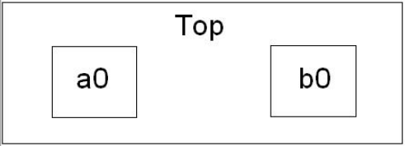

Hierarchy File
top {top}
| a {a0}
| b {b0}

Interfaces
Set of CSL interfaces that specify the interfaces for each of the blocks that are used in the design
The interface is described only once and can be used in several places making it highly maintainable.

The unique part of the implementation is that the preprocessor generates the following code or equivalent object model. The interface which is specified on one row in the connection table is automatically converted into the following interconnect elements:
- Interface declarations in the endpoints
- If necessary the interface is reversed
- The hierarchical identifiers/interface instance names and connection actual name are inserted into the correct units

If this method was not automated then the user would have to put the interface instances in the end point units and add the reverse statement if necessary and in addition would have to determine the HID path names manually. Changes to the connection statements and associated endpoints is time consuming.

Example interface:
csl_interface ifc {
csl_port ready(output);
csl_port valid(output,32);
csl_port stall(input);
}

Connection Table
CSL  Type | From  Instance  Name | From  CSL  Type  Name | To  Instance  Name | To  CSL  Type  Name | Actual  Name
ifc | a0 | ifc0 | b0 | ifc0 | a_b

The following is the generated CSL code or the object model from the preprocessor. The connection statements and the interface declarations are shown in red in the code below.

// interface library file
csl_interface ifc {
csl_port ready(output);
csl_port valid(output,32);
csl_port stall(input);
}

// generated CSL code
csl_unit a {
ifc ifc0;
a() {}
}

csl_unit b {
ifc ifc0;
b() { ifc0.reverse();}
}

csl_unit top {
a a0; b b0;
top() {
a0.ifc0.connect_by_name(b0.ifc0, a_b);
}
}

Interconnect Methodology
The following steps are taken when developing a chip design hierarchy and interconnect.

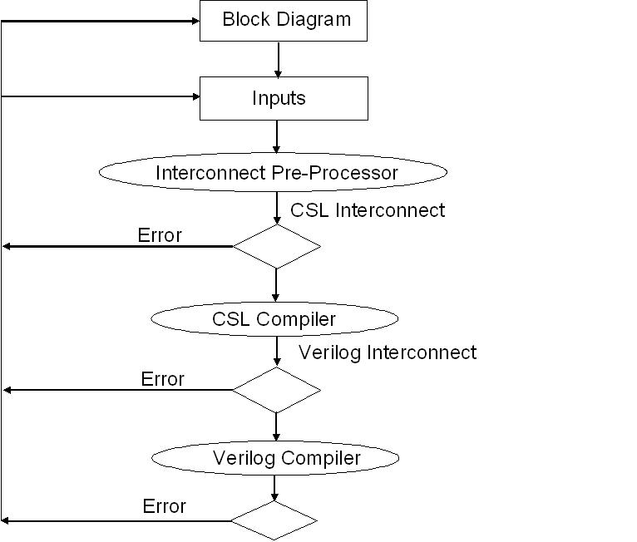

Steps
- The block diagram shows the names of the blocks and a line between blocks that are connected. Each line is labeled with a number and represents many signals or interfaces
- A hierarchy file is created which represents the hierarchy of the chip using module and instance names
- A CSL library file is created which represents the interfaces that connect the units in the diagram
- Create the CSL file specifying the interconnect or use the CSL spreadsheet tool to list all the interfaces and then automatically generate the CSL file
- Run the CSL compiler with code generators turned off to check for any CSL specification errors and fix the inputs if necessary
- If no errors, re-run the CSL compiler to generate the synthesizable RTL and C++ reference model code
- Compile the generated RTL and user RTL to check for errors and fix the inputs including the block diagram, CSL, & user RTL
- If no errors, RTL interconnect has been successfully generated and user RTL has been integrated at the leaf-level
- Compile the generated C++ and user C++ to check for errors and fix the inputs including the block diagram, CSL, & user C++
- If no errors, C++ interconnect has been successfully generated and user C++ has been integrated at the leaf-level
- Changes to inputs
- Design hierarchy
- Add or delete units at any level
- Add or delete intermediate levels
- Connections
- Add, delete, or change types, widths, names, directions
- Once changes are made, re-run compiler to ensure that all changes are correctly captured
ADVANTAGES:
Single specification language with highly compact representation.

Ability to completely separate the hierarchy and interfaces from the connections.

Automatic generation of interconnect and intermediate connections in both the RTL and reference modules as well as the interfaces for the transaction level modeling testbenches.

Point to point connections are made across several levels of hierarchy with a single statement instead of detailed intermodule connections at each hierarchy level.

Changes to interfaces are automatically propagated to the generated connections.

Ports can be added, deleted, and modified and the changes are automatically propagated to all units that connections between instances of that interface travel through thus making the specification easily maintainable.

The interconnect and design hierarchy is tied to the other parts of the design which can also be described at an architectural or high level such as the register file memory map, registers, FIFO's, register files, memories, pipelines, and instruction set architecture.

